The Rifleman’s Rule

Laser rangefinders designed for hunters have the ability to measure the distance to a target, and the angle of elevation/depression to it. From these two quantities, many rangefinders on the market will calculate and display a third quantity. This quantity varies in name from manufacturer to manufacturer; but for the sake of this worksheet we’ll refer to it as the ‘effective distance’. This quantity is useful when shooting up or down hills, as projectiles will travel a slightly different distance when shot on a hill compared to across a horizontal field. Hunters, who calibrate their sights on a flat field (which is all of them), will find their shots up or down hills will often miss the target if they don’t correct for it. While many rangefinders calculate and display the corrected effective distance for you, their user’s manuals usually don’t tell you what formula they use to calculate it; all we know about it is that the calculation only incorporates the distance to the target, $R_{S}$, and the angle of elevation/depression, $α$. The goal of this fill-in-the-blanks worksheet is to workout what that formula is for ourselves.

Question 1: Fired at an angle of $dθ$ above the horizon, how for will a projectile travelling at an initial speed $v_{i}$ go?

Here’s a sketch to help us work through this problem:

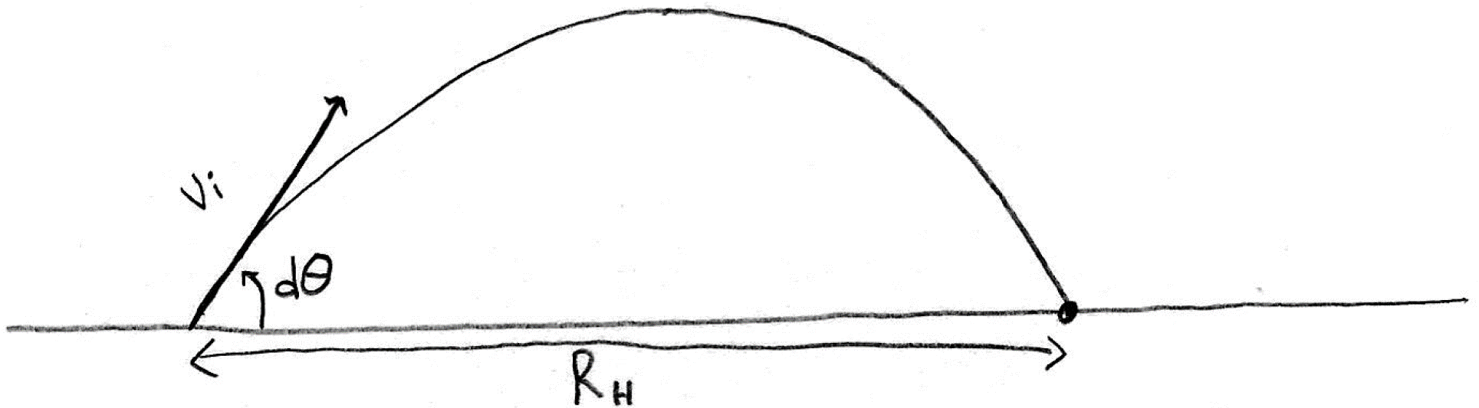

We’ll let $R_{H}$ represent the horizontal range. Let’s solve this problem by first analyzing only the motion in the vertical direction:

$$∆\vec{d}={\vec{v}}_{i}∆t+\frac{1}{2}\vec{a}{\left(∆t\right)}^{2} \\ ∆{\vec{d}}_{y}={\vec{v}}_{iy}∆t+\frac{1}{2}{\vec{a}}_{y}{\left(∆t\right)}^{2} \\ 0=\left(v_{i}\sin\left(dθ\right) \left[\text{up}\right]\right)∆t+\frac{g \left[\text{down}\right]}{2}{\left(∆t\right)}^{2} \\ 0=v_{i}\sin\left(dθ\right)∆t \left[\text{up}\right]-\frac{g}{2}{\left(∆t\right)}^{2} \left[\text{up}\right] \\ \frac{g}{2}{\left(∆t\right)}^{2} \left[\text{up}\right]=v_{i}\sin\left(dθ\right)∆t \left[\text{up}\right] \\ ∆t=\frac{2v_{i}\sin\left(dθ\right)}{g}\text{ Equation ①}$$

Next, let’s analyze only the motion in the horizontal direction:

$$∆\vec{d}={\vec{v}}_{i}∆t+\frac{1}{2}\vec{a}{\left(∆t\right)}^{2} \\ ∆{\vec{d}}_{x}={\vec{v}}_{ix}∆t+\frac{1}{2}{\vec{a}}_{x}{\left(∆t\right)}^{2} \\ R_{H} \left[\text{right}\right]=\left(v_{i}\cos\left(dθ\right) \left[\text{right}\right]\right)∆t+\frac{1}{2}\left(0\right){\left(∆t\right)}^{2} \\ R_{H} \left[\text{right}\right]=v_{i}\cos\left(dθ\right)\left(\frac{2v_{i}\sin\left(dθ\right)}{g}\right) \left[\text{right}\right]+0 \\ R_{H}=\frac{2v_{i}^{2}\sin\left(dθ\right)\cos\left(dθ\right)}{g} \\ R_{H}=\frac{v_{i}^{2}\left(2\sin\left(dθ\right)\cos\left(dθ\right)\right)}{g} \\ R_{H}=\frac{v_{i}^{2}\sin\left(2dθ\right)}{g}$$
Thus, a projectile shot at an angle of $dθ$ above the horizon, at an initial speed $v_{i}$, will horizontally travel:

$$\boxed{R_{H}=\frac{v_{i}^{2}\sin\left(2dθ\right)}{g}}\text{ Equation ②}$$

Question 2: Fired at an angle of $dθ$ above a hill already at an angle α above the horizon, how far along the hill would the projectile go?

Here’s a sketch to help us work through this problem:

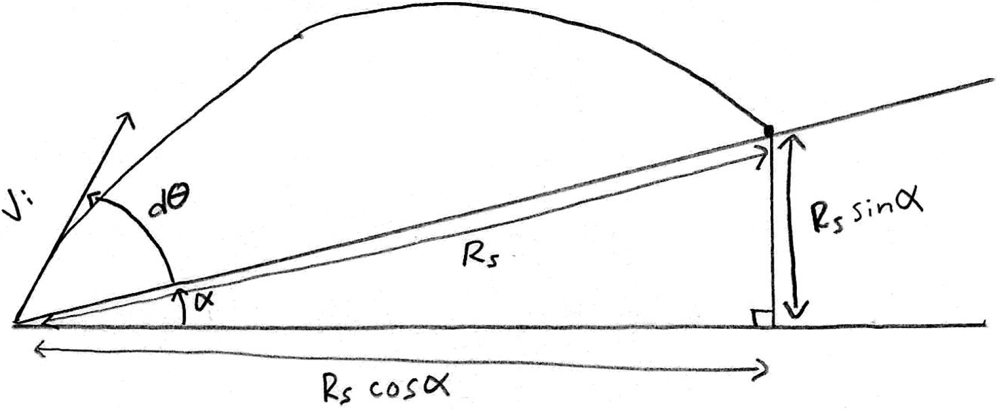

We’ll let $R_{S}$ represent the slant range and solve this problem by first analyzing the motion in the horizontal direction:

$$∆{\vec{d}}_{x}={\vec{v}}_{ix}∆t+\frac{1}{2}{\vec{a}}_{x}{\left(∆t\right)}^{2} \\ R_{S}\cos{α} \left[\text{right}\right]=\left(v_{i}\cos\left(dθ+α\right)\left[\text{right}\right]\right)∆t+\frac{1}{2}\left(0\right){\left(∆t\right)}^{2} \\ R_{S}\cos{α} \left[\text{right}\right]=v_{i}\cos\left(dθ+α\right)∆t \left[\text{right}\right]+0 \\ \frac{R_{S}\cos{α}}{v_{i}\cos\left(dθ+α\right)}=∆t\text{ Equation ③}$$
Next, let’s analyze only the motion in the vertical direction:

$$∆{\vec{d}}_{y}={\vec{v}}_{iy}∆t+\frac{1}{2}{\vec{a}}_{y}{\left(∆t\right)}^{2} \\ R_{s}\sin{α} \left[\text{up}\right]=\left(v_{i}\sin\left(dθ+α\right)\left[\text{up}\right]\right)∆t+\frac{g \left[\text{down}\right]}{2}{\left(∆t\right)}^{2} \\ R_{s}\sin{α} \left[\text{up}\right]=v_{i}\sin\left(dθ+α\right)\left(\frac{R_{S}\cos{α}}{v_{i}\cos\left(dθ+α\right)}\right) \left[\text{up}\right]-\frac{g}{2}{\left(\frac{R_{S}\cos{α}}{v_{i}\cos\left(dθ+α\right)}\right)}^{2} \left[\text{up}\right] \\ R_{s}\sin{α}=R_{s}\cos{α}\tan\left(dθ+α\right)-\frac{gR_{S}^{2}\cos^{2}{α}}{2v_{i}^{2}\cos^{2}\left(dθ+α\right)} \\ \frac{gR_{S}^{2}\cos^{2}{α}}{2v_{i}^{2}\cos^{2}\left(dθ+α\right)}=R_{s}\cos{α}\tan\left(dθ+α\right)-R_{s}\sin{α} \\ R_{S}=R_{s}\left(\cos{α}\tan\left(dθ+α\right)-\sin{α}\right)\left(\frac{2v_{i}^{2}\cos^{2}\left(dθ+α\right)}{gR_{s}\cos^{2}{α}}\right) \\ R_{S}=\frac{2v_{i}^{2}}{g\cos^{2}{α}}\cos^{2}\left(dθ+α\right)\left(\cos{α}\tan\left(dθ+α\right)-\sin{α}\right) \\ R_{S}=\frac{2v_{i}^{2}}{g\cos^{2}{α}}\cos^{2}\left(dθ+α\right)\left(\frac{\cos{α}\sin\left(dθ+α\right)}{\cos\left(dθ+α\right)}-\frac{\sin{α}\cos\left(dθ+α\right)}{\cos\left(dθ+α\right)}\right) \\ R_{S}=\frac{2v_{i}^{2}}{g\cos^{2}{α}}\cos^{2}\left(dθ+α\right)\left(\frac{\cos{α}\sin\left(dθ+α\right)-\sin{α}\cos\left(dθ+α\right)}{\cos\left(dθ+α\right)}\right) \\ R_{S}=\frac{2v_{i}^{2}}{g\cos^{2}{α}}\cos\left(dθ+α\right)\left(\sin\left(dθ+α-α\right)\right) \\ R_{S}=\frac{2v_{i}^{2}}{g\cos^{2}{α}}\cos\left(dθ+α\right)\sin\left(dθ\right) \\ R_{S}=\frac{2v_{i}^{2}\sin\left(dθ\right)}{g\cos^{2}{α}}\cos\left(dθ+α\right) \\ R_{S}=\frac{2v_{i}^{2}\sin\left(dθ\right)}{g\cos^{2}{α}}\left(\cos{dθ}\cos{α}-\sin{dθ}\sin{α}\right) \\ R_{S}=\frac{2v_{i}^{2}\sin\left(dθ\right)\cos{dθ}}{g\cos^{2}{α}}\left(\cos{α}-\frac{\sin{dθ}\sin{α}}{\cos{dθ}}\right) \\ R_{S}=\frac{2v_{i}^{2}\sin\left(dθ\right)\cos{dθ}}{g\cos{α}}\left(\frac{\cos{α}}{\cos{α}}-\frac{\sin{dθ}\sin{α}}{\cos{dθ}\cos{α}}\right) \\ R_{S}=\frac{2v_{i}^{2}\sin\left(dθ\right)\cos{dθ}}{g\cos{α}}\left(1-\tan{dθ}\tan{α}\right) \\ R_{S}=\frac{v_{i}^{2}\left(2\sin\left(dθ\right)\cos{dθ}\right)}{g}\left(1-\tan{dθ}\tan{α}\right)\left(\frac{1}{\cos{α}}\right) \\ R_{S}=\frac{v_{i}^{2}\sin\left(2dθ\right)}{g}\left(1-\tan{dθ}\tan{α}\right)\left(\sec{α}\right)$$
Thus, the projectile will travel a slant distance of:

$$\boxed{R_{S}=\frac{v_{i}^{2}\sin\left(2dθ\right)}{g}\left(1-\tan{dθ}\tan{α}\right)\left(\sec{α}\right)}\text{ Equation ④}$$

Now let’s stop and think about how these variables apply to the hunter. $dθ$ is the angle above the horizon of which a projectile is launched, which depends on how far away the target is. For example, if you want to hit a target that is 100 yards away, you would need to aim slightly higher than if you were trying to hit something 20 yards away. The hunter has calibrated their sights so that whatever distance the target is away (across a flat field), $R_{H}$, the hunter can choose an appropriate angle, $dθ$, that would reliably hit the target.

Question 3: Given the target is on a hill at an angle of $α$ and is a distance of $R_{S}$ away (according to the rangefinder), what value of $R_{H}$ should be chosen so that the hunter corrects for the hill and hits their mark?

To solve this, take equation ② and insert it into equation ④, then solve for the unknown variable $R_{H}$ in terms of only the variables that the hunter could measure, $dθ$, $α$ and $R_{S}$.

$$R_{S}=\frac{v_{i}^{2}\sin\left(2dθ\right)}{g}\left(1-\tan{dθ}\tan{α}\right)\left(\sec{α}\right) \\ R_{S}=R_{H}\left(1-\tan{dθ}\tan{α}\right)\left(\sec{α}\right) \\ \frac{R_{S}}{\left(1-\tan{dθ}\tan{α}\right)\left(\sec{α}\right)}=R_{H} \\ \frac{R_{S}\cos{α}}{1-\tan{dθ}\tan{α}}=R_{H}$$

Thus, given your target is a distance of $R_{S}$ away, on a hill at an angle of $α$ above (it can be shown that this same result holds for below too) the horizon, you would want to aim as though you were shooting a target that was this distance away from you on a horizontal field:

$$\boxed{R_{H}=\frac{R_{S}\cos{α}}{1-\tan{dθ}\tan{α}}}\text{ Equation }\text{⑤}$$

Question 4: Assume $dθ$ is fairly small (which is the case for bows, and is especially for firearms) and simplify equation ⑤ with an approximation.

Note that $\tan{θ}≈0$ if $dθ$ is small. Furthermore, if $α<45°$ (which would otherwise be a very steep hill), then $\tan{α}<1$. The product of a number that is close to zero, and another number less than 1, should be even closer to zero than the first number was to begin with, so let’s make the reasonable approximation that $\tan{dθ}\tan{α}≈0$. Then we can simplify this as follows:

$$R_{H}=\frac{R_{S}\cos{α}}{1-\tan{dθ}\tan{α}} \\ R_{H}≈\frac{R_{S}\cos{α}}{\left(1-0\right)} \\ R_{H}≈\frac{R_{S}\cos{α}}{1} \\ R_{H}≈R_{S}\cos{α}$$

Thus, given your target is a distance of $R_{S}$ away, on a hill at an angle of $α$ above or below the horizon, you would want to aim as though you were shooting a target that was this distance away from you on a horizontal field:

$$\boxed{R_{H}≈R_{S}\cos{α}}\text{ Equation }\text{⑥}$$

Question 5: What does the value of $R_{S}\cos{α}$ physically represent to the hunter?

If we draw a diagram, you can see that $R_{S}$ represents the slant distance, and $R_{S}\cos{α}$ represents the horizontal component of the distance to the target.

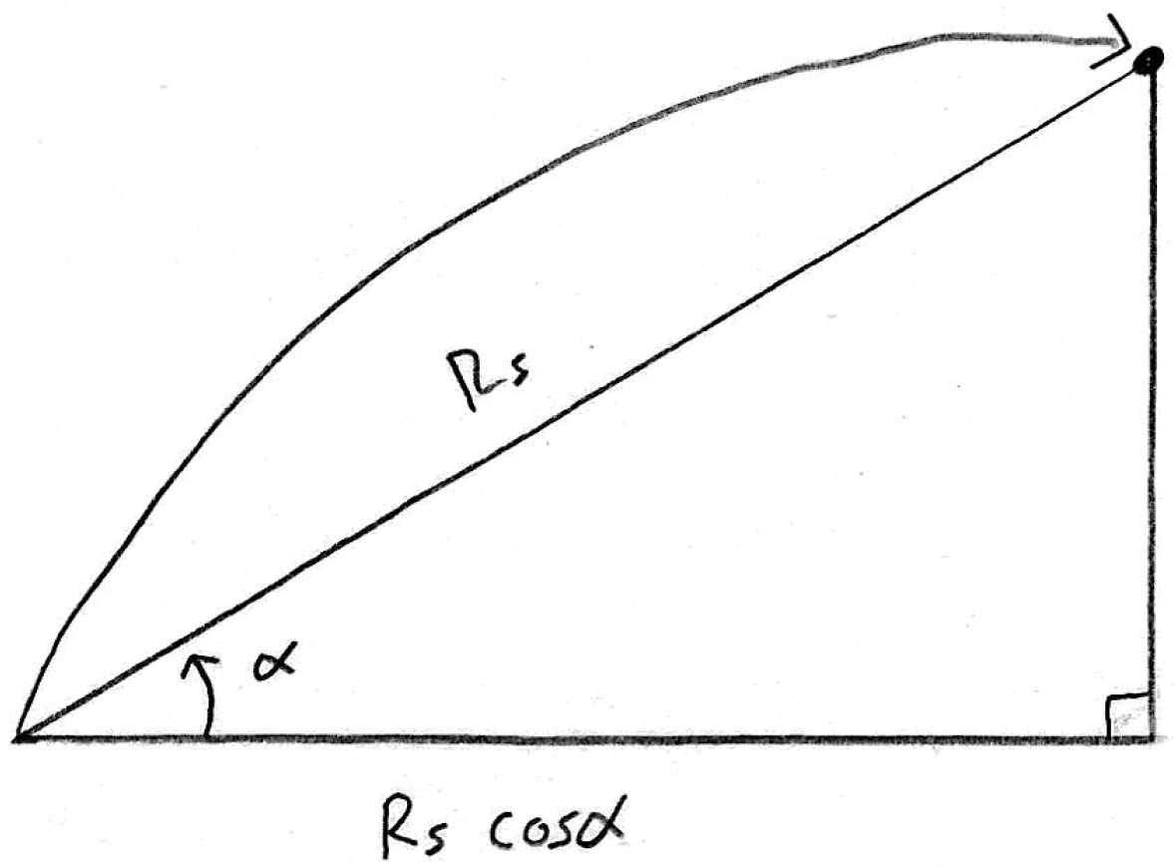

What an amazing coincidence! If the hunter’s target is on a hill, some horizontal distance away from them, then the hunter would simply want to aim as though the target was indeed that horizontal distance away from them, but across an open field.

$$\boxed{R_{H}≈\text{the horizontal component of the distance to the target} }\text{ Equation }\text{⑦}$$

This rule of thumb is referred to as the ‘rifleman’s rule’, and gives a fairly reliable approximation to how you should aim on hills. Equation ⑤, $R_{H}=\frac{R_{S}\cos{α}}{1-\tan{dθ}\tan{α}}$, is the true form of the rifleman’s rule, but most hunters and laser rangefinders use the simpler $R_{H}≈R_{S}\cos{α}$ instead. There are several reasons for this; first of all, $R_{S}\cos{α}$ is a lot faster and easier to calculate than $\frac{R_{S}\cos{α}}{1-\tan{dθ}\tan{α}}$. Secondly, $dθ$ changes from hunter to hunter, bow to bow, and firearm to firearm, so there would be no way of programming that into the rangefinder at the factory. The third reason is that hunters typically don’t measure $dθ$, so even if the rangefinder allowed hunters to program their personal value for $dθ$ in, most people wouldn’t bother.
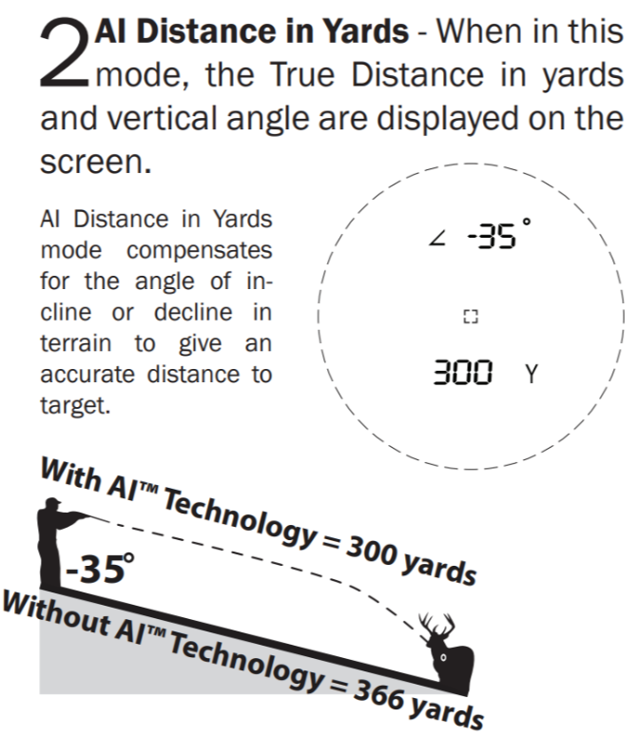
Question 5: To check if this is indeed the equation that some laser rangefinders use, let’s compare our equation ⑥ to an example provided on page 7 of the user’s manual for the HALO model # Z6X laser rangefinder. As can be seen in the picture, a hunter is shooting at a target that is 366 yards away, located $35°$ below the horizon, and should aim as though the target were effectively 300 yards away across a flat field.

$$R_{H}≈R_{S}\cos{α} \\ ≈\left(366\text{ yd}\right)\cos\left(-35°\right) \\ ≈300\text{ yd}$$

Notice that our result agrees with the example provided in the user’s manual, so it seems very likely that the equation the rangefinder is using is the rifleman’s rule, $R_{H}=R_{S}\cos{α}$.

Question 6 (Bonus): We have shown that
$R_{H}=\frac{R_{S}\cos{α}}{1-\tan{dθ}\tan{α}}≈R_{S}\cos{α}$ applies when shooting uphill. Prove that the same formula works for shooting downhill.

