Diffraction Gratings and Crystallography Name _______________

Prior Knowledge: Light passing through multiple slits with a spacing d, will create an interference pattern which can be described by sin (θ_{n}) = n λ/d or x_{n} = nλL/d if the angle is small.
- You have a laser pointer and a diffraction grating. Hold the diffraction grating parallel to a horizontal surface and point a laser beam down through it. Sketch the pattern you get in the space below and write down any other observations.

The central spot is much brighter than the ones on the side. There may also be another faint pair of dots further out. Rotating the grating will rotate the pattern by the same amount. The separation of spots is greater as the distance from the grating to the table is increased. Tilting the grating causes an asymmetric pattern.

The asymmetry can be explained with the following diagrams.

You can get diffractions gratings here https://www.sargentwelch.com/store/product/8885837/replica-diffraction-gratings for about a dollar each. They are mounted in 2”x2” cardboard slides and have 5360 lines per cm, a separation of 1.6 μm. These show very strong spots for n = 1 and may also show faint spots for the second order, but only if the leaser is bright and the room dark.
- PEOE: What you will see if you have two horizontal gratings?
The students Predict, Explain their predictions, Observe and then Explain if the observations are different.

2 parallel gratings 2 anti-parallel gratings 2 gratings, 20º apart
Notice how the last patterns two form ‘X’s. This will be very important when we get to DNA.

- PEOE: What will you see if the beam goes through a piece of cloth?

There is an ‘X’ pattern formed of more dots and which are much closer together. This is because the spacing of the threads is so much smaller than the grating spacing. Remind them that sin(θ) = n λ /d and that sin(θ) can’t be greater than 1. This is best done as a demonstration with the screen and fabric as far apart as possible. A good, white cloth (handkerchief, curtain sheer etc.) works well. The understanding can be reinforced with crossed gratings that have a large spacing.

- Make appropriate measurements and calculate the separation between the slits of a single diffraction grating. Describe your technique and show your steps below.
Students should hold the grating far from the screen, so that L and x are large so that the precision will be greater. For the same reason, they should measure the distance between the two outside spots and then divide by 2. The angle formed is not small so they can’t use the formula x_{n} = nλL/d. They should use tan (θ_{n}) = x_{n}/L to find the angle and then use the angle and sin (θ) = n λ/d to find d.

- Crystals have atoms that are arranged in regular rows and these can act like diffraction gratings. The picture below left was obtained using zinc sulfide in 1912 by the Nobel Prize-winning father and son team of William Lawrence Bragg and William Henry Bragg.
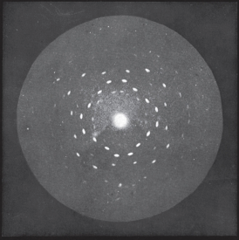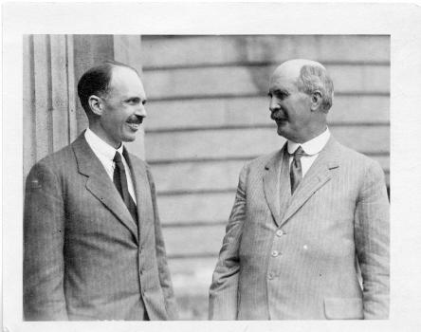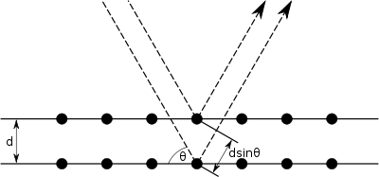
- In what way does this image resemble the interference patterns you’ve seen? What does this tell you about the ZnS sample?
There are many dots, like the fabric and course gratings. This shows that the spacing is large compared to the wavelength of the light. There are more than four dots at the same radius, which means that there must be several crystals at different orientations, similar to what can seen with multiple diffraction gratings.
- The light used to make the image was in the x-ray part of the spectrum with a wavelength smaller than half a nanometre. Roughly how far apart are atomic layers in the crystal?
Looking along one radius from the center, you can see at least three dots, so n can be as large as that. For the largest order of interference, the sine will be close to one. Therefore the spacing will be around a couple of nanometers.
- The image below is called Photo 51 and it is the most famous x-ray crystallography image. It and was made by Rosalind Franklin in 1952 and was critical in determining the double helix structure of DNA.
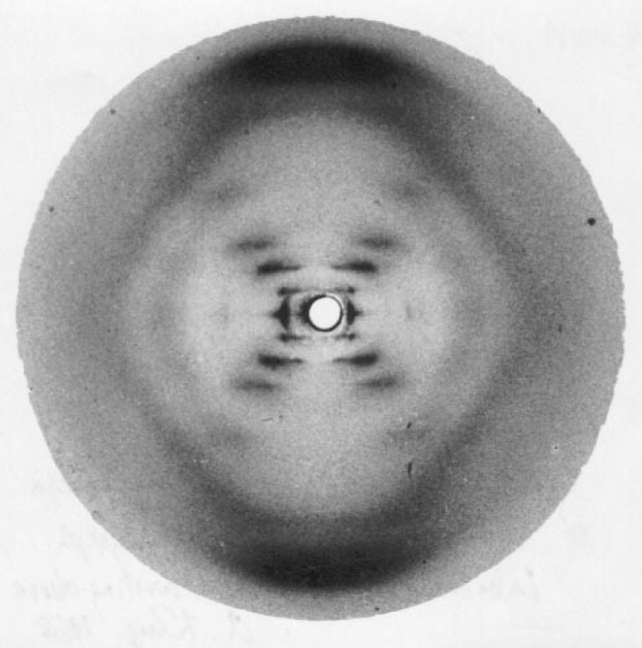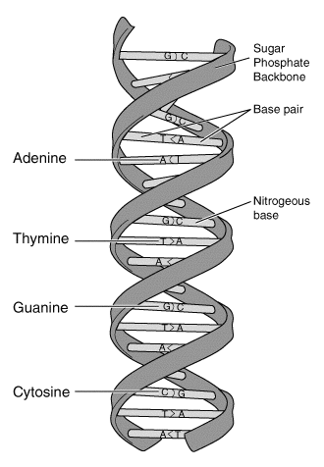
- Look at the diffraction pattern formed when a laser beam passes through the side of a small metal spring. How is this pattern similar to Fig. 51?
The pattern will form an X with many spots. The ‘X’ is what we saw with crossed gratings. To see the pattern you need a bright laser pointer in a dark room. Make sure that the batteries are fresh and use a green laser pointer if you have one. The spring from a pen works well. Place the coil as far from the screen as far as possible to make the pattern large. The wire needs to be sufficiently thick that it blocks the direct laser beam that can drown out the pattern. Franklin had the same problem and you can see a circle in the center where she blocked the direct beam.
- Why does the pattern form an ‘X’? Hint: How is the side view of the spring similar to crossed diffraction gratings?
Look at the diagram of the model above and look at a spring from the side. They both look like crossed diffraction gratings. The lines with a positive slope make the pattern with a negative slope and vice versa. The angle between the two diagonal lines depends on the pitch of the helix. If you take a tight coil and stretch it, the lines will form a larger angle.

- Franklin used measurements from this image to calculate that the bases that form the rungs of the DNA ladder must be separated by 0.34 nm. The number of blobs in each diagonal line tells you how many bases are stacked on top of each other within each turn. Therefore, how tall is one twist?
There are ten blobs and each is 0.34 nm, so the total distance is 3.5 nm. For more detail go to
https://mrc.ukri.org/news/blog/behind-the-picture-photo-51/?redirected-from-wordpress

- Watch DNA diffraction with a LASER! || MinuteLaboratory #14 (1:49 minutes)

https://www.youtube.com/watch?v=y0v2rZvNU2c What else can measurements of the interference pattern tell you about the coil? The large interference spacing is due to the width of the wire and the small spacing is due to the separation of each coil. This is like a double slit interference pattern that fades away periodically due to the single slit interference pattern. The angle helps determine the pitch.

This video does the demo with a stretched light bulb coil. I tried this and don’t recommend it. It is much harder and the coil was so thin that much of the laser beam went straight through and made it hard o see the fainter X.

The 1962 Nobel Prize for discovering the structure of DNA went to James Watson, Francis Crick and Maurice Wilkins – but not Rosalind Franklin. The prize is only awarded to living people and Franklin died of cancer in 1958 of cancer, which was possibly caused by her exposure to x-rays. The Nobel Prize can only be split up to three ways. Which three would have won the Nobel Prize if Rosalind had lived? Watch James Watson on X-ray crystallographer Rosalind Franklin (2:36 minutes) https://www.youtube.com/watch?v=r6p_T9qLLfU (2:36) and consider the following;

i) Watson and Crick did the theoretical model building together..

ii) Rosalind’s crystallography and calculations provided them with essential clues.

iii) Wilkins’s crystallography provided confirmation of the model afterward they had made it.

iv) Franklin and Wilkins were both working at King’s College London, but they did not get along.

v) Wilkins was friends with Crick.

vi) Watson wrote a popular book in which he was dismissive and insulting about Franklin

vii) Only Crick ever gave credit to Franklin’s work and that was decades later.

Historians are almost unanimous that Rosalind should have got the prize, had she lived. Because she didn’t get the prize her work was almost forgotten. There are many institutions and awards named after her in an attempt to right the injustice. For more details go to go to https://profiles.nlm.nih.gov/ps/retrieve/Narrative/KR/p-nid/187 and https://physicstoday.scitation.org/doi/10.1063/1.1570771

