Diffraction Gratings and Crystallography Name _______________

- You have a laser pointer and a diffraction grating. Hold the diffraction grating parallel to a horizontal surface and point a laser beam down through it. Sketch the pattern you get in the space below and write down any other observations.

- PEOE: What you will see if you have two horizontal gratings?

.

- PEOE: What will you see if the beam goes through a piece of cloth?

- Make appropriate measurements and calculate the separation between the slits of a single diffraction grating. Describe your technique and show your steps below.

- Crystals have atoms that are arranged in regular rows and these can act like diffraction gratings. The picture below left was obtained using zinc sulfide in 1912 by the Nobel Prize-winning father and son team of William Lawrence Bragg and William Henry Bragg.
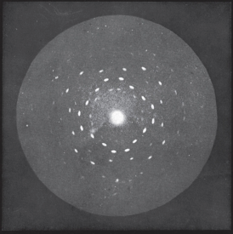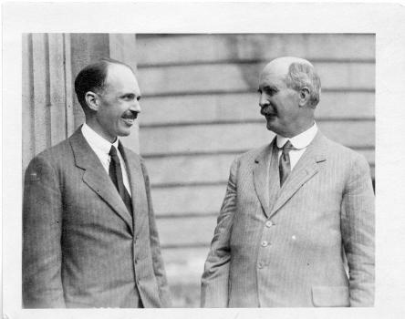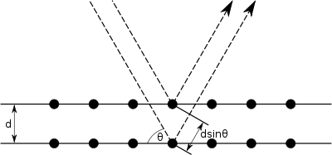
- In what way does this image resemble the interference patterns you’ve seen? What does this tell you about the ZnS sample?

- The light used to make the image was in the x-ray part of the spectrum with a wavelength smaller than half a nanometre. Roughly how far apart are atomic layers in the crystal?
.

- The image below is called Photo 51 and it is the most famous x-ray crystallography image. It and was made by Rosalind Franklin in 1952 and was critical in determining the double helix structure of DNA.
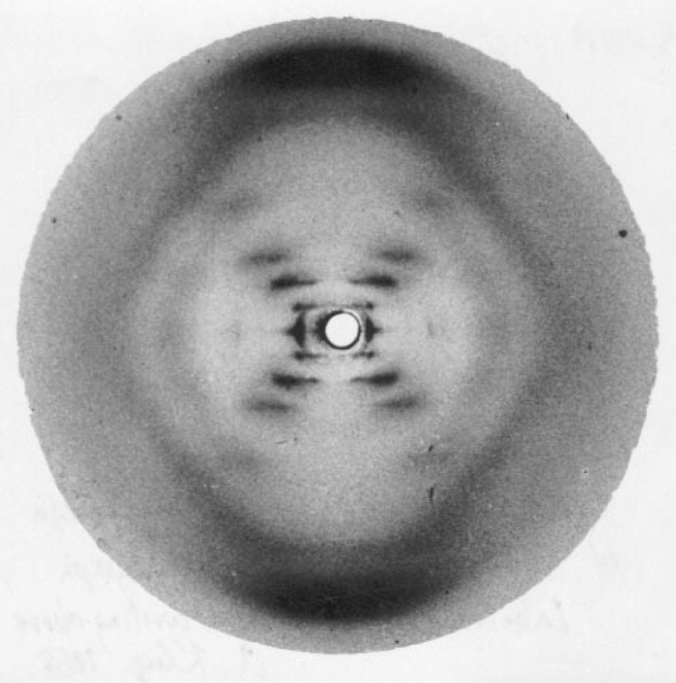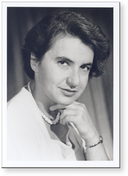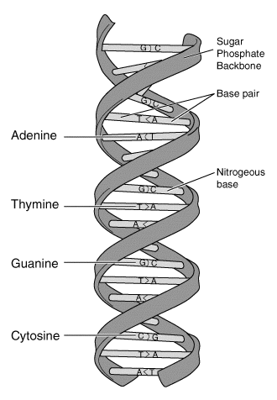
- Look at the diffraction pattern formed when a laser beam passes through the side of a small metal spring. How is this pattern similar to Fig. 51?

- Why does the pattern form an ‘X’? Hint: How is the side view of the spring similar to crossed diffraction gratings?

- Franklin used measurements from this image to calculate that the bases that form the rungs of the DNA ladder must be separated by 0.34 nm. The number of blobs in each diagonal line tells you how many bases are stacked on top of each other within each turn. Therefore, how tall is one twist?

- Watch DNA diffraction with a LASER! || MinuteLaboratory #14 (1:49 minutes)

https://www.youtube.com/watch?v=y0v2rZvNU2c What else can measurements of the interference pattern tell you about the coil?

The 1962 Nobel Prize for discovering the structure of DNA went to James Watson, Francis Crick and Maurice Wilkins – but not Rosalind Franklin. The prize is only awarded to living people and Franklin died of cancer in 1958 of cancer, which was possibly caused by her exposure to x-rays. The Nobel Prize can only be split up to three ways. Which three would have won the Nobel Prize if Rosalind had lived? Watch James Watson on X-ray crystallographer Rosalind Franklin (2:36 minutes) https://www.youtube.com/watch?v=r6p_T9qLLfU (2:36) and consider the following;

i) Watson and Crick did the theoretical model building together.

ii) Rosalind’s crystallography and calculations provided them with essential clues.

iii) Wilkins’s crystallography provided confirmation of the model afterward they had made it.

iv) Franklin and Wilkins were both working at King’s College London, but they did not get along.

v) Wilkins was friends with Crick.

vi) Watson wrote a popular book in which he was dismissive and insulting about Franklin

vii) Only Crick ever gave credit to Franklin’s work and that was decades later.

