The spinning fish tank

Consider a fish tank half-filled with water, imagine what would happen to the water when the tank is rotated around its centre.
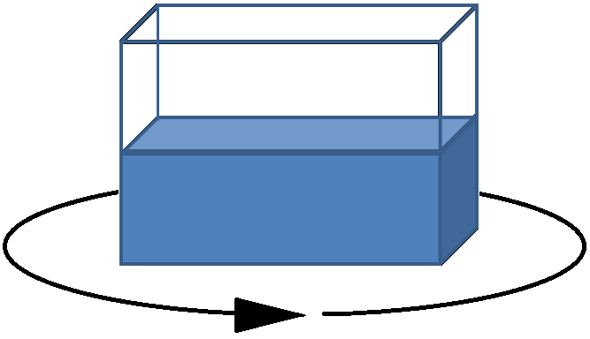
Figure 1: A diagram showing a stationary fish tank half-filled with water, and the direction that it will soon be rotated in.

- Draw a picture of your prediction here.

The shape that the water makes can be determined experimentally, consider the following images showing how the water looks at various speeds.

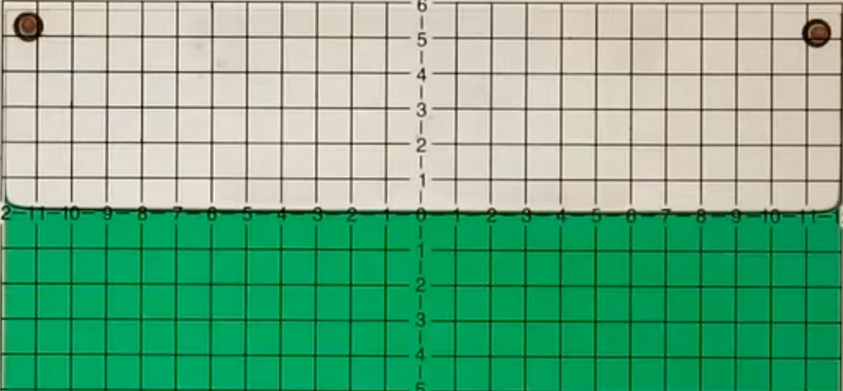
Figure 2: At rest, the water level will be flat, as shown above.

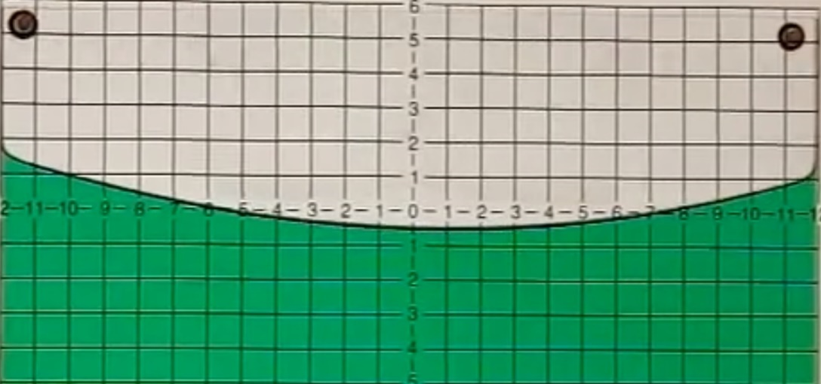
Figure 3: In the fish tank’s frame of reference, as the speed increases, the imaginary centrifugal force begins pushing the water outwards.

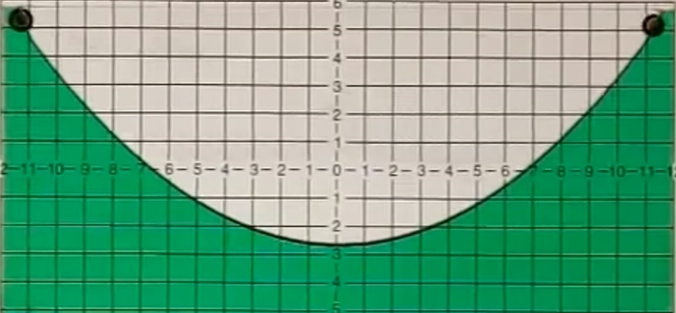
Figure 4: The faster the rotations, the more the water is pushed outwards to the sides.

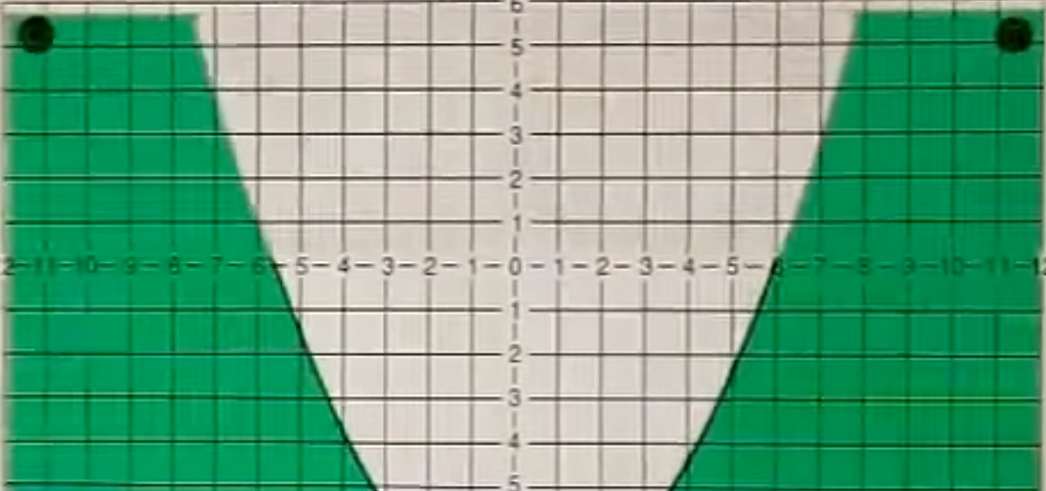
Figure 5: When the tank spins really fast, no water at all remains in the middle.

- Compare figures 2 to 5 to your sketch from question 1). Does your sketch agree with the experimental results?

Hopefully it does.

Again, look at figures 2 to 5. These all have the same kind of mathematical shape, though some are stretched more than others.

- What kind of mathematical shape does the water look like to you?

A parabola.

- What is the general mathematical formula for that shape?

$$y=a{\left(x-h\right)}^{2}+k$$

- Solve for the values of the numerical constants in your equation from question 4) for the curve shown in figure 3.

The parabola has its vertex at $\left(0,-2.6\right)$, so $h=0$ and $k=-2.6$. To find the value of $a$, which represents the amount of stretch, sub in any point on the curve, other than the vertex.
$$y=a{\left(x-0\right)}^{2}-2.6 \\ y=ax^{2}-2.6 \\ 1=a{\left(8\right)}^{2}-2.6 \\ 3.6=64a \\ 0.05625=a$$
Thus $y≈0.05625x^{2}-2.6$.

- Fill in the table below, and then plot the points onto figure 3 to confirm that your equation makes a good fit.
$$x$$ | $$y$$ | $$x$$ | $$y$$
0 | -2.6 | 1 | -2.54375
-1 | -2.54375 | 2 | -2.375
-2 | -2.375 | 3 | -2.09375
-3 | -2.09375 | 4 | -1.7
-4 | -1.7 | 5 | -1.19375
-5 | -1.19375 | 6 | -0.575
-6 | -0.575 | 7 | 0.15625
-7 | 0.15625 | 8 | 1
-8 | 1 | 9 | 1.95625
-9 | 1.95625 | 10 | 3.025
-10 | 3.025 | 11 | 4.20625
-11 | 4.20625 | 12 | 5.5

Now let’s try to find out why this happens, using physics. When something is submerged in a liquid, it feels a pressure pushing on it. The deeper you submerge an object under water, the more pressure it feels crushing in on it from all directions. Pressure is equal to the amount of force pushing on an object, per surface area. Mathematically,

$$P=\frac{F}{A}$$

where $F$ is the amount of force pushing on the object, $A$ is the surface area of the object, and $P$ is the pressure applied on the object, measured in newtons per square metre. If you’ve ever dove down to the bottom of a swimming pool, you’ve probably noticed you felt a high pressure, and water probably got into your ears when you did. The more water that is above you, the more weight of it you’ll feel. Water-pressure increases linearly with depth, the relationship being

$$P=ρ_{f}gh$$

where $ρ_{f}$ is the density of the displaced fluid (not the density of the object displacing the fluid), $g$ is the acceleration due to gravity, and $h$ is the depth of the object in the water.

In order to find what shape the surface of the water makes, let’s not talk about the water itself, but instead suppose we place a single fish into the half-filled, rotating fish tank. To keep things as simple as possible, let’s assume the fish is roughly in the shape of a cube, henceforth, we’ll call it a cubefish. Also, so that the fish behaves like the water would, assume the cubefish has the same density as the water around it, which is actually a fairly good approximation.

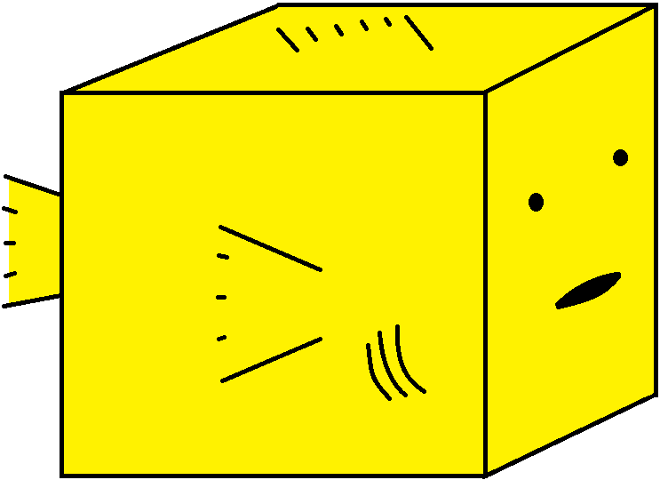
Figure 6: What our cube-fish looks like.

Note that for our submerged cubefish the pressure pushing up on the bottom of the fish is greater than the pressure pushing down on the top of the fish. This is because the bottom of the fish is deeper and water pressure increases with depth. The cubefish would of course rise upwards because of this, if not for the fact that gravity is pulling it down. The upwards water pressure, the smaller, downwards water pressure, and the downwards force of gravity will all sum to zero, and the cubefish will be in vertical equilibrium. We’re more interested in the pressure pushing in on the sides of the cubefish. Since the top of the water isn’t flat, the depth of the cubefish changes based on which side of the fish you’re considering. The leftward and rightward inward forces won’t balance each other out. Let’s say the left side of the fish is at a depth of $h_{2}$ and the right side is at a depth of $h_{1}$.

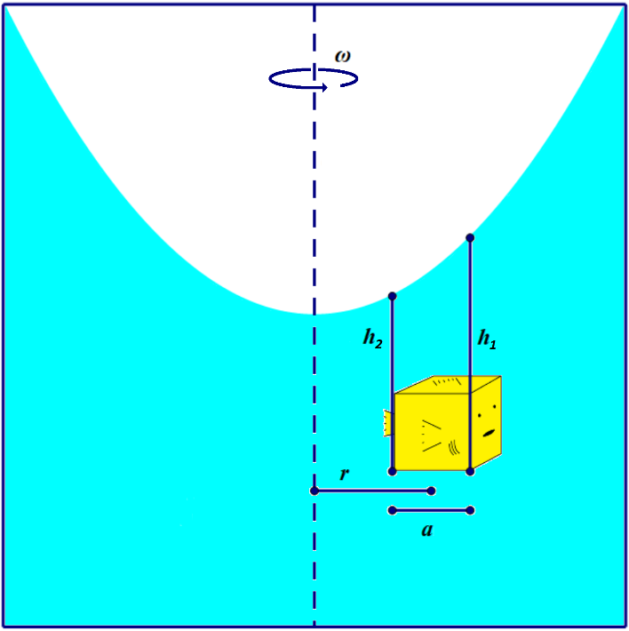
Figure 7: The coordinate system we’ll use for a cubefish at rest in a rotating fish tank.
- Rewrite $P=ρ_{f}gh$ in terms of a force. Recall that $P=\frac{F}{A}$, and assume the cubefish has side length $a$.

$$P=ρ_{f}gh \\ \frac{F}{A}=ρ_{f}gh \\ F=ρ_{f}ghA \\ F=ρ_{f}gha^{2}$$

- Find an expression for the horizontal net force of the water pushing in on the cubefish.

$${\vec{F}}_{net}=ρ_{f}gh_{1}a^{2}\text{ [left]}+ρ_{f}gh_{2}a^{2}\text{ [right]+}ρ_{f}g\left(\frac{h_{1}+h_{2}}{2}\right)a^{2}\text{ [out of the page]}+ρ_{f}g\left(\frac{h_{1}+h_{2}}{2}\right)a^{2}\text{ [into the page]} \\ =ρ_{f}gh_{1}a^{2}A\text{ [left]}-ρ_{f}gh_{2}a^{2}\text{ [left]}+ρ_{f}g\left(\frac{h_{1}+h_{2}}{2}\right)a^{2}\text{ [out of the page]}-ρ_{f}g\left(\frac{h_{1}+h_{2}}{2}\right)a^{2}\text{ [out of the page]} \\ =ρ_{f}g\left(h_{2}-h_{1}\right)a^{2}\text{ [left]}+0 \\ =ρ_{f}g\left(h_{2}-h_{1}\right)a^{2}\text{ [left]}$$

- How much force is required to keep the cubefish going around in a circle at a constant speed, $v$, and constant radius, $r$?

$${\vec{F}}_{net}={\vec{F}}_{c} \\ =\frac{mv^{2}}{r}\text{ [radially inwards]}$$

- Rewrite the expression you got in question 9) in terms of $ω$, the angular speed of the fish tank measured in radians per second. Recall $ω=\frac{v}{r}$.

$${\vec{F}}_{net}=\frac{mv^{2}}{r}\text{ [radially inwards]} \\ =\frac{m{\left(ωr\right)}^{2}}{r}\text{ [radially inwards]} \\ =mω^{2}r\text{ [radially inwards]}$$

- Combine your answers to questions 8) and 10). Use the fact that $ρ=\frac{m}{V}$ to simplify your result.

$${\vec{F}}_{net}={\vec{F}}_{net} \\ ρ_{f}g\left(h_{2}-h_{1}\right)a^{2} \text{[left]}=mω^{2}r \text{[radially inwards]} \\ ρ_{f}g\left(h_{2}-h_{1}\right)a^{2}=ρVω^{2}r \\ ρg\left(h_{2}-h_{1}\right)a^{2}=ρa^{3}ω^{2}r \\ g\left(h_{2}-h_{1}\right)=aω^{2}r \\ \frac{h_{2}-h_{1}}{a}=\frac{ω^{2}}{g}r$$

- Your previous result should be equivalent to $\frac{h_{2}-h_{1}}{a}=\frac{ω^{2}}{g}r$. If your answer to question 11) looks different, go back and try to rearrange it so it looks the same.

Now let’s consider the equation

$$\frac{h_{2}-h_{1}}{a}=\frac{ω^{2}}{g}r$$

in more detail. Notice that the left-hand side is equivalent to the slope, $m=\frac{∆y}{∆x}=\frac{h_{2}-h_{1}}{a}$. This is literally the slope you would expect to find any cubefish in the tank to be at, meaning that if you had a bunch of fish in the tank, they would not remain horizontally, but at an angle. Now imagine replacing that fish with a cubic centimetre of water, it too would be at an angle, since it had the same density as the fish. So, the slope of the fish and the slope of the water at the surface are the same, since we know the slope of the fish, we know what the slope of the water will be. On the right side of the equation you can see a dependence on $ω^{2}$. This tells us that the faster the tank is spun, the steeper the fish and also the water level at the surface will be. There is also a dependence on $r$, this means that the further you are from the centre, the steeper the fish and the water level will be. The dependence on $g$ doesn’t really impact the experiment for us, however if you repeated this experiment on the moon, the slope of the fish and the water would be greater.

- If you’re currently taking or already took calculus, then you’ve probably seen a function where the slope $\left(\frac{h_{2}-h_{1}}{a}\right)$ is equal to a constant $\left(\frac{ω^{2}}{g}\right)$ multiplied by the variable $x$ $\left(r\right)$. What kind of mathematical function satisfies that equation of $m=kx$, or equivalently, what kind of a function has a derivative that is linear? If you haven’t taken calculus, from grade 10 you might be able to recall a function whose second differences are constant, what kind of function satisfied that condition?

A parabola has a derivative that is linear. The equation of the parabola must be $y=\frac{kx^{2}}{2}$.

$$y=\frac{kx^{2}}{2} \\ \frac{dy}{dx}=\frac{k\left(2x\right)}{2} \\ m=kx \\ \frac{h_{2}-h_{1}}{a}=\left(\frac{ω^{2}}{g}\right)r$$

- Does the result from question 13) agree with your answer to question 3)? If not, double check your answer to question 12).

Yes! In question 3) we said the surface of the water looked parabolic, which we found to be the case in question 12).

Now go to https://www.youtube.com/watch?v=f8IwL2ZtDTc to watch a video of fish in a half-filled, rotating fish tank. Notice that the fish are usually on an angle, often parallel to the water surface.
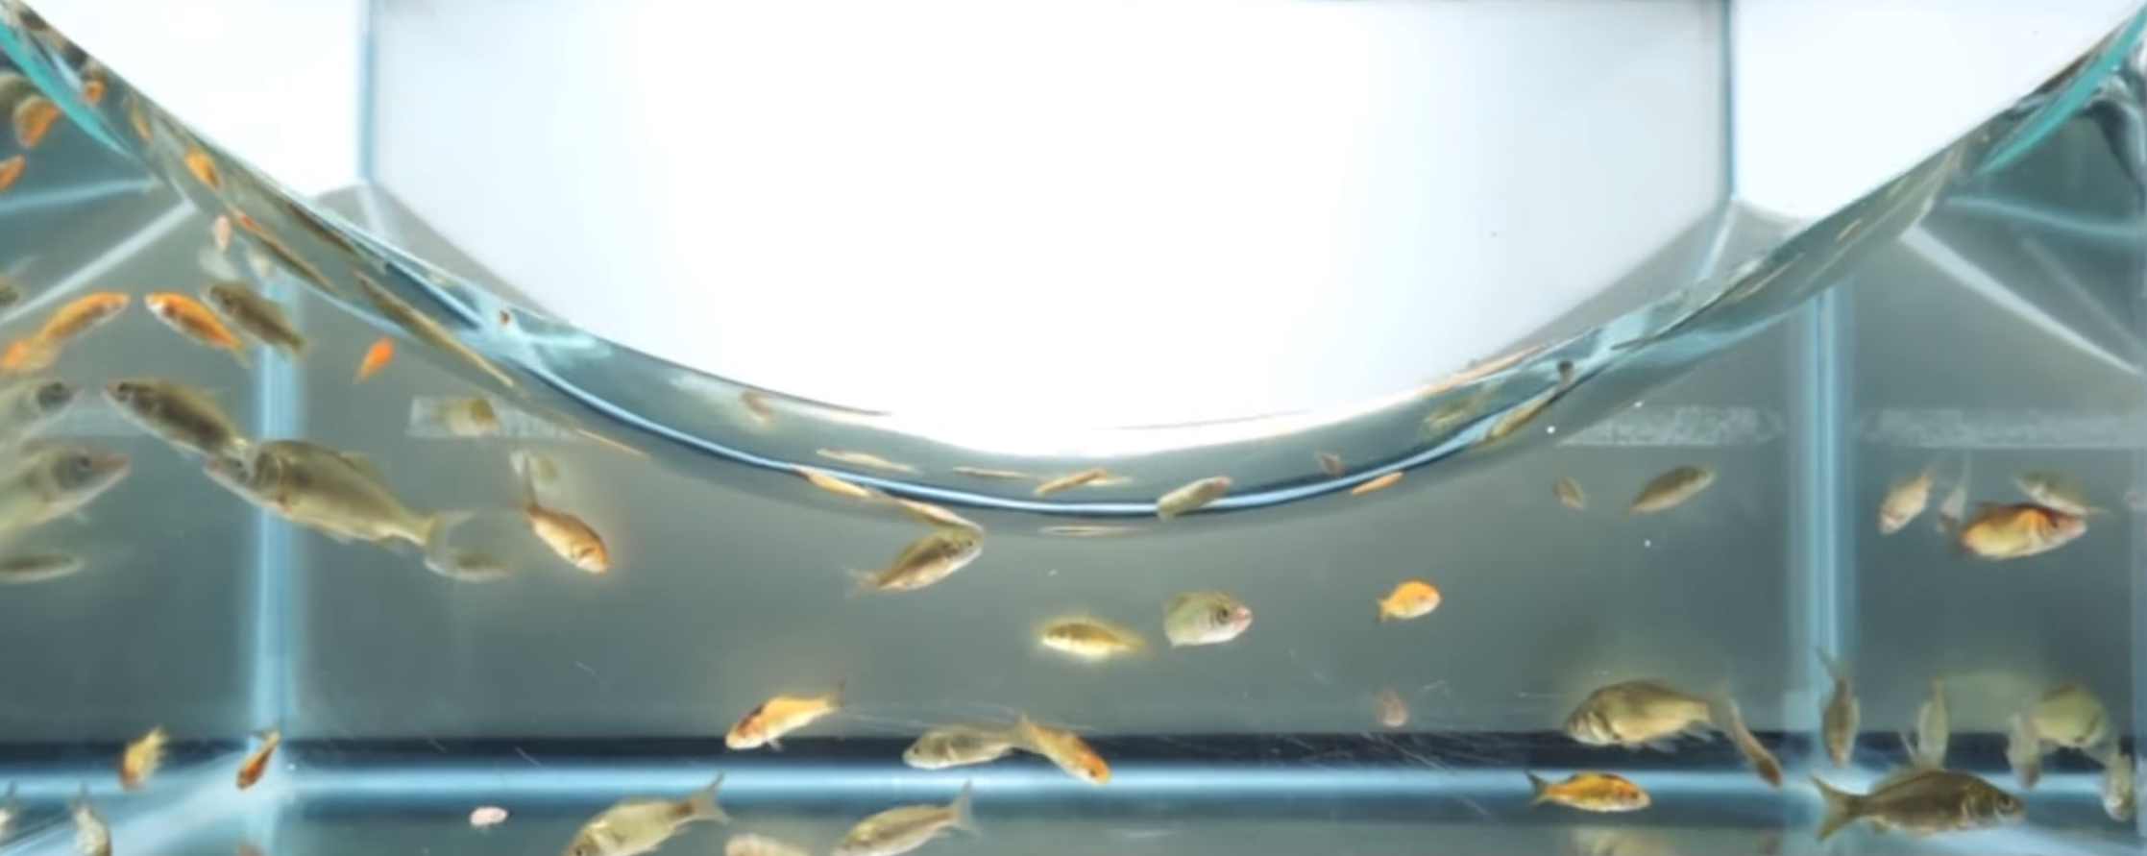
Figure 8: Fish swimming in a fish tank which is rotating around its centre.
In astronomy, parabolic mirrors are used to build telescopes because they have a focal point where all the incoming parallel light is reflected to, which is where you might place a camera or a secondary mirror directing that light to your eye.

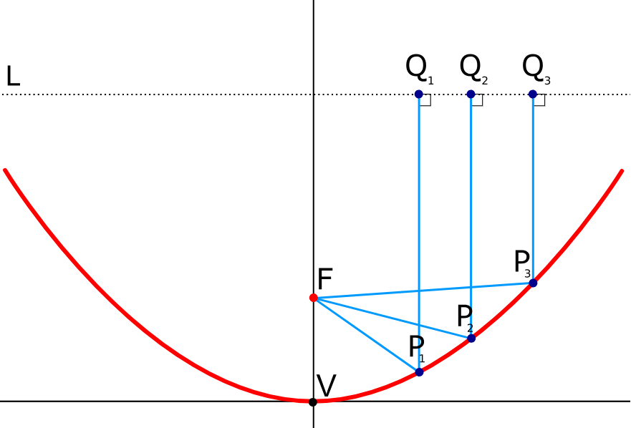
Figure 9: A parabolic reflector showing how incoming, parallel light is all reflected towards a focal point.
https://en.wikipedia.org/wiki/Parabolic_reflector#/media/File:Parabola_with_focus_and_arbitrary_line.svg

To build such reflectors you can melt and spin glass around in a circle and let it cool and solidify at a constant angular speed. Alternatively, you can ‘construct’ a parabolic mirror by spinning liquid mercury around. Since mercury doesn’t solidify, you have to keep spinning it for it to work, but the advantage of this is you can alter the focal length at will by simply slowing down or speeding up the rate of rotation. Such mirrors are used in what are called ‘liquid mirror telescopes’, like the one shown below.

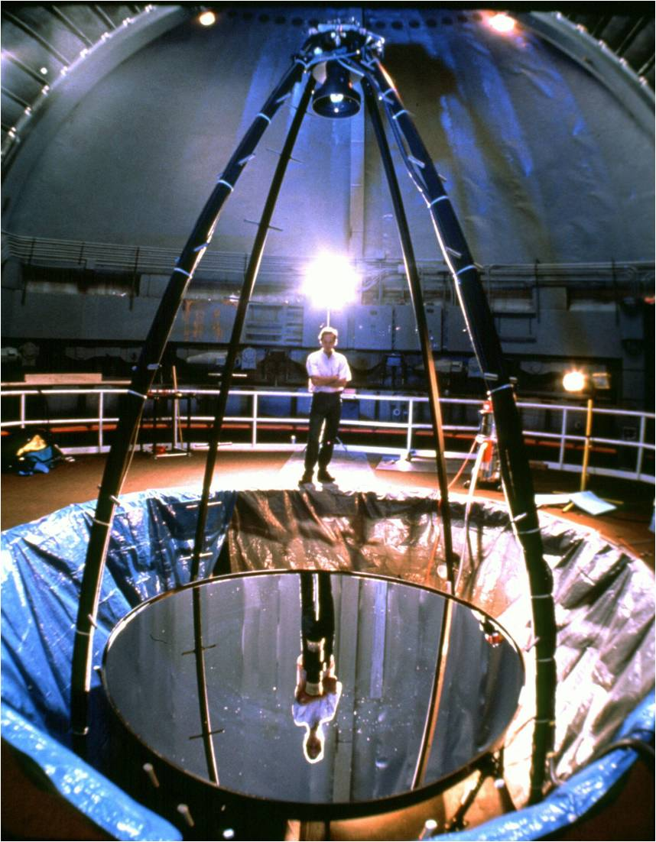
Figure 10: A liquid mirror telescope.
https://en.wikipedia.org/wiki/File:Liquid_Mirror_Telescope.jpg

