Measuring Pressure Handout

Student Name: Date:

Many people have a misconception as to how drinking-straws function, thinking that when someone sucks on a straw, they ‘pull’ the liquid (let’s assume the liquid is water) up the straw. This is wrong! When you start sucking the air out of a straw, you create a region of lower-pressure air inside the straw. While this air does have a lower pressure when compared to the rest of the air in the environment, it is still somewhat pressurized, and should therefore push the water in the straw down; not ‘pull’ it up.

But then why does the water go up the straw? The water inside the straw goes up because the rest of the water in the cup is being compressed by the atmospheric pressure! Since the pressure from the atmosphere pushing down on the surface of the water in the cup is stronger than the pressure of the air pushing down on the water inside the straw, the water will go up the straw. It is very important to realize that the water doesn’t get ‘pulled’ up by the drinker, but gets ‘pushed’ up by the surrounding atmospheric pressure.

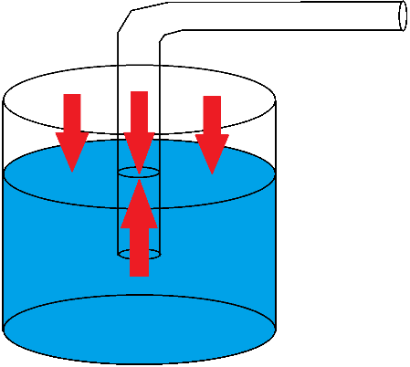
Figure 1: A diagram showing a straw partially submerged in water, with pressures depicted by the arrows. Note that both the air and the water are equally pressurized.

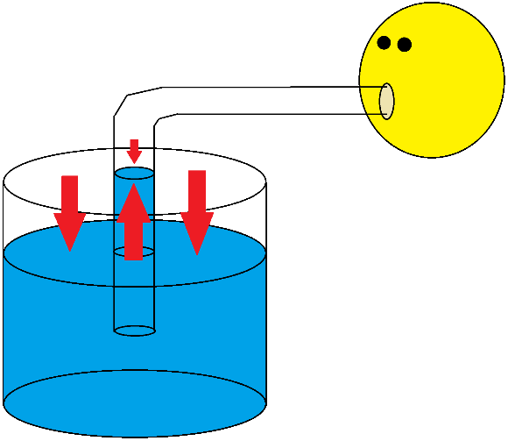
Figure 2: A diagram showing someone sucking on a straw, with pressures depicted by the arrows. Note the smaller arrow indicating a smaller pressure.

Okay, so why is this all so important? Well, even if you were able to create a perfect vacuum with your mouth, since the atmospheric pressure can only push so hard, the water will only ever go so high up the straw. At some point the force from the pressure in the atmosphere pushing the column of water up the straw would become balanced by the weight of the water column inside the straw itself, and the water would stop rising when it reaches that equilibrium. In this activity, we’ll calculate how high water can go up a straw, and find out how low of a pressure a student in our class can create with their mouth.

- Complete the calculation below, showing how high water can go up a straw with a perfect vacuum.

$${\vec{F}}_{\text{net}}=0 \\ {\vec{F}}_{\text{g}}+{\vec{F}}_{\text{atmospheric pressure}}=0 \\ F_{\text{g}}\left[\text{down}\right]+F_{\text{atmospheric pressure}}\left[\text{up}\right]=0 \\ F_{\text{g}}\left[\text{down}\right]=-F_{\text{atmospheric pressure}}\left[\text{up}\right] \\ F_{\text{g}}\left[\text{down}\right]=F_{\text{atmospheric pressure}}\left[\text{down}\right] \\ F_{\text{g}}=F_{\text{atmospheric pressure}} \\ mg=PA \\ DVg=PA \\ DhAg=PA \\ Dhg=P \\ h=\frac{P}{Dg} \\ =\frac{101325\text{ Pa}}{\left(997 {\text{kg/m}}^{3}\right)\left(9.8 {\text{m/s}}^{2}\right)} \\ =10.37039691\frac{{\text{N/m}}^{2}}{{\text{N/m}}^{3}} \\ =10.4\text{ m}$$

- When we had a student suck water up the long tube, how high up did it go?

Answers may vary, let’s assume 6.00 m.

- Since it was less than 10.4 m, the student did not create a perfect vacuum, but did create a region with significantly less than 1 atm (101325 Pa) of pressure. Using the height they achieved, fill in the calculation below, and find the reduced pressure that the student was able to create.

$${\vec{F}}_{\text{net}}=0 \\ {\vec{F}}_{\text{g}}+{\vec{F}}_{\text{atmospheric pressure}}+{\vec{F}}_{\text{straw pressure}}=0 \\ F_{\text{g}}\left[\text{down}\right]+F_{\text{atmospheric pressure}}\left[\text{up}\right]+F_{\text{straw pressure}}\left[\text{down}\right]=0 \\ F_{\text{atmospheric pressure}}\left[\text{up}\right]-F_{\text{straw pressure}}\left[\text{up}\right]=-F_{\text{g}}\left[\text{down}\right] \\ \left(P_{\text{atmosphere}}A-P_{\text{straw}}A\right)\left[\text{up}\right]=F_{\text{g}}\left[\text{up}\right] \\ P_{\text{atmosphere}}A-P_{\text{straw}}A=F_{\text{g}} \\ \left(P_{\text{atmosphere}}-P_{\text{straw}}\right)A=mg \\ \left(P_{\text{atmosphere}}-P_{\text{straw}}\right)A=DVg \\ \left(P_{\text{atmosphere}}-P_{\text{straw}}\right)A=DAhg \\ P_{\text{atmosphere}}-P_{\text{straw}}=Dhg \\ P_{\text{atmosphere}}-Dhg=P_{\text{straw}} \\ 101325\text{ Pa}-\left(997 {\text{kg/m}}^{3}\right)\left(6.00\text{ m}\right)\left(9.8 {\text{m/s}}^{2}\right)=P_{\text{straw}} \\ 101325\text{ Pa}-58623.6 {\text{N/m}}^{2}=P_{\text{straw}} \\ 42701.4\text{ Pa}=P_{\text{straw}}$$

- Write that pressure as a percentage of the standard atmospheric pressure.

$$\text{\% pressure}=\frac{P_{\text{straw}}}{P_{\text{atmosphere}}}×100\% \\ =\frac{42701.4\text{ Pa}}{101325\text{ Pa}}×100\% \\ =42.1\%$$
- At standard atmospheric pressure, with a perfect vacuum, calculate how high the mercury in a mercury-barometer would rise to. Note that mercury is much heavier than water, it has a density of 13593 kg/cm³.

$$h=\frac{P}{Dg} \\ =\frac{101325\text{ Pa}}{\left(13593 {\text{kg/m}}^{3}\right)\left(9.8 {\text{m/s}}^{2}\right)} \\ =0.760633099 \frac{{\text{N/m}}^{2}}{{\text{N/m}}^{3}} \\ =0.760 \text{m} \\ =760 \text{mm}$$

- Why do scientists prefer barometers filled with mercury, which is both hard-to-purchase, and toxic, as opposed to water?

Because a water barometer would need to be about 10.4 m tall, which requires three storeys of space; whereas a mercury barometer only needs to be about 76 cm tall, which would fit on top of a desk.

- In this experiment, we used water. If we had used a juice with a high sugar-content instead, what would that change, and how would that have affected the height that the juice rose to compared to the water?

The density of the liquid would increase, and since $h=\frac{P}{Dg}$, a small increase in density would cause the height the student was able to achieve to go down a small amount.

