**Background**

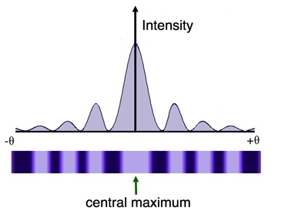When a laser beam is passed through a single slit light, it forms a diffraction pattern on a screen whose intensity follows the distribution shown below. The brightness or intensity can be viewed as a measure of the number of photons reaching the screen. Before passing through the slit, the photons have momenta which are perpendicular to the width of the slit. After passing through the slit some of the photons have momenta with a component parallel to the slit. This means that the photon’s momentum has changed when passing through the slit. This is a result of the uncertainty principle. By passing through the slits, the uncertainty of the location of the photons has a maximum value of . According to the uncertainty principle this results in an increase in the uncertainty of the momentum of the photons since

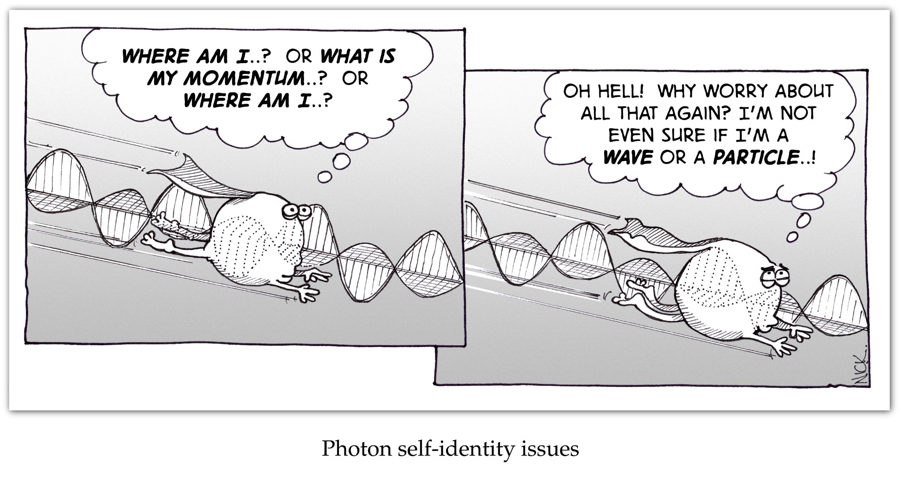



By decreasing the uncertainty in the location of the photons within the slit we are increasing the uncertainty the spread in their momenta. This results in the intensity pattern’s width spreading as w gets smaller. Note this is usually only significant when the width of the slit is comparable to the wavelength of the light used.

Since the momentum of the photons is given by  , blue photons have a higher momentum than red photons. This also will affect the spread in the momentum and we should see this as a change in the width of the pattern.

**Materials**

Red, blue and green laser pointers (these can be purchased from laserbud.com for $8.99 each), single slits of varying sizes, and a sheet of 8.5 x 11 blank paper

**Procedure**

1. Subdivide your piece of paper as shown below

|  |  |  |  |
| --- | --- | --- | --- |
|  | red | green | blue |
| Wide |  |  |  |
| Medium |  |  |  |
| Narrow |  |  |  |

1. Illuminate the widest single slit and trace the central bright spot on the piece of blank paper in the appropriate box with a red laser.
2. Repeat for two more slits with decreasing widths so that you have a pattern for a wide slit a medium wide slit and a narrow slit.
3. Repeat steps one and two using both a green and a blue laser
4. If possible, add colour to your diagrams

**Discussion**

1. Compare and contrast the patterns for the wide slit, medium slit and narrow slit. What does this tell you about the relationship between the width of the slits and the width of the pattern?
2. Compare and contrast the patterns for the wide slit for the three wavelengths (colours) of light. What does this tell you about the relationship between the wavelength of light and the width of the pattern?
3. How does this experiment demonstrate the uncertainty principle?